Predicting Kickstarter Project State

March 11, 2018

DePaul University

CSC 478 Final Project

Sidney Fox - 1524992

Rebecca Tung - 1448196

I. Introduction 3

II. Overview 3

III. Analysis of Features and Observations 4

IV. Initial Transformations 9

V. Feature Importance 9

VI. Additional Transformations 12

VII. Model Execution and Analysis of Results 13

VIII. Conclusion 15

IX. Appendix 16

# Introduction

The purpose of this document is to outline our approach in predicting the status of different projects presented to the public using the Kickstarter platform. The group leveraged many algorithms and functions available in the sklearn library to operationalize the defined machine learning workflow. This document will provide an overview of the dataset leveraged to complete the machine learning project, as well as an in-depth analysis of the methodologies implemented, the requisite results, and any conclusions, as well as constraints or blockers, the group was able to identify while completing the project.

# Overview

The dataset used to complete the group's analysis can be found on the Kaggle website as a competition dataset.[1] There are two datasets listed under the competition page. After a comparison of both datasets, it was determined that both datasets contain the same information in terms of relevant data points. The most recent dataset, entitled "ks-projects-201801.csv", contains a "cleansed" dataset, where all of the misnomers and formatting issues have been removed and / or rectified. After conducting this analysis, the group determined that the only dataset required to complete the project was the ks-projects-201801.csv. All of the analysis presented throughout this document solely references this dataset. After settling on the ks-projects-201801.csv dataset, the group created a GitHub repository and uploaded the .csv file in question to said repository. The group used GitHub to build their analysis leveraging the same base dataset, and complete the necessary objectives independently, within a central repository.

Concerning an overview of the features of the dataset specifically, the table below contains relevant high-level statistics in terms of row count and number of columns below:

|  |  |
| --- | --- |
| Statistic | Value |
| Number of Rows | 378,661 |
| Number of Columns | 15 |

In addition to the number of rows and columns, the feature names and corresponding data types can be found on the next page.

|  |  |  |
| --- | --- | --- |
| Sequence Number | Column Name | Data Type |
| 1 | ID | Numeric |
| 2 | name | String |
| 3 | category | String |
| 4 | main_category | String |
| 5 | currency | String |
| 6 | deadline | DateTime |
| 7 | goal | Numeric |
| 8 | launched | DateTime |
| 9 | pledged | Numeric |
| 10 | state | String |
| 11 | backers | Numeric |
| 12 | country | String |
| 13 | usd pledged | Numeric |
| 14 | usd_pledged_real | Numeric |
| 15 | usd_goal_real | Numeric |

Once the dataset was identified, the group conducted a deeper dive of the data – analyzing features as well as observations.

# Analysis of Features and Observations

To gain better insight into the data, the group produced a series of histograms to show distributions by different segments of the data. Please find a histogram, as well as a summary table, of project status below.

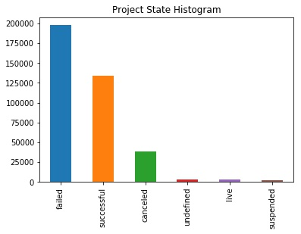

|  |  |
| --- | --- |
| Project State | Observation Count |
| failed | 197,719 |
| successful | 133,956 |
| canceled | 38,779 |
| ~~undefined~~ | ~~3,562~~ |
| ~~live~~ | ~~2,799~~ |
| suspended | 1,846 |

From the information presented in this histogram and corresponding summary table, one can easily determine that most projects fail, with projects succeeding being the second most frequent project state. Aside from projects succeeding, applicable statuses include "canceled", "undefined", "live", and "suspended". The group decided to keep all statuses aside from "undefined" and "live", due to the ambiguity associated with the undefined project state, and the in-flight status of a live project.

Removing the "undefined" and "live" status reduced the total dataset record count to 375,000. Aside from removing observations where the project state was equal to undefined, the group also removed features *goal*, *pledged*, and *usd pledged*. The dataset contains Kickstarter campaigns from a number of different countries, with the stated goal and pledged values in the native currency. The creator of the dataset converted the goal and pledged amounts to United States Dollars (usd). This conversion is represented in the dataset as *usd_pledged_real* and *usd_goal_real*. Removal of the aforementioned columns reduces the number of meaningful numeric variables to three – *usd_pledged_real*, *usd_goal_real*, and *backers*. Summary statistics for these variables are shown in the following table.

|  |  |  |  |
| --- | --- | --- | --- |
| Statistic | backers | usd_goal_real | usd_pledged_real |
| count | 372300.000000 | 3.723000e+05 | 3.723000e+05 |
| mean | 106.910040 | 9.148405e+03 | 4.572162e+04 |
| std | 914.235813 | 9.170345e+04 | 1.151326e+06 |
| min | 0.000000 | 0.000000e+00 | 1.000000e-02 |
| 25% | 2.000000 | 3.122000e+01 | 2.000000e+03 |
| 50% | 12.000000 | 6.280000e+02 | 5.500000e+03 |
| 75% | 57.000000 | 4.066000e+03 | 1.598542e+04 |

After producing high level summary statics for the numeric variables, the group produced a correlation matrix using the *pearson* method to view any weak or strong relationships within the original data. A heatmap was produced to present the relationships graphically.

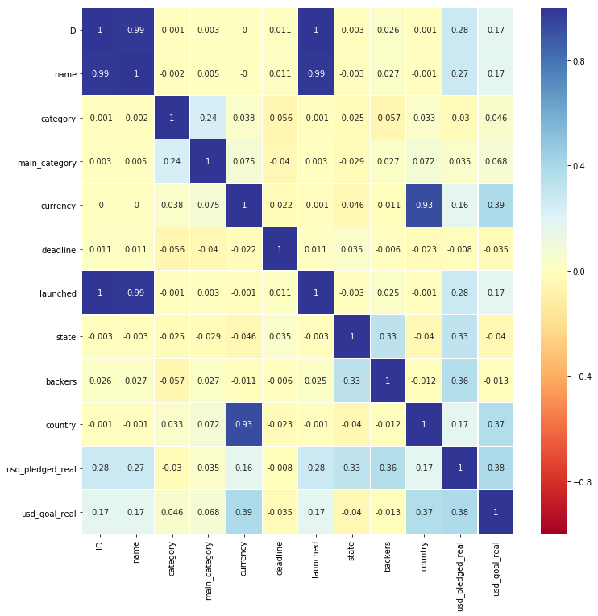

The elicited results show strong relationships between *ID* and *name* (correlation = 0.99), *launched* and *name* (correlation = 0.99), as well as *country* and *currency* (correlation = 0.93). There are also marginally strong relationships between *usd_pledged_real* and *usd_pledged_goal* (correlation = 0.38), *usd_pledged_real* and *state* (correlation = 0.33), as well as *backers* and *state* (correlation = 0.33). Based on the operational understanding of the data, this is to be expected. The number of backers positively drive the amount pledged for a given project, and are influential in a project being successful.

Once correlations were identified, the group focused their analysis on the relationship between *main_category* and *category*. The *main_category* feature is a parent of the *category* feature, with 170 categories available and fifteen distinct main categories. A breakdown of observations by *main_category* can be found in the following table, as well as a corresponding histogram.

|  |  |
| --- | --- |
| Main Category | Observation Count |
| Art | 28,153 |
| Comics | 10,819 |
| Crafts | 8,809 |
| Dance | 3,767 |
| Design | 30,068 |
| Fashion | 22,813 |
| Film & Video | 62,731 |
| Food | 24,602 |
| Games | 35,230 |
| Journalism | 4,755 |
| Music | 49,684 |
| Photography | 10,778 |
| Publishing | 39,412 |
| Technology | 32,566 |
| Theater | 10,912 |

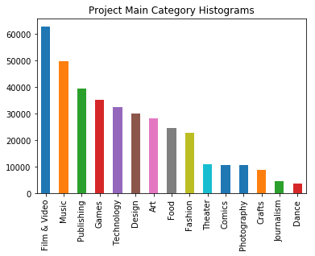

Based on this analysis, the top three categories in terms of observation count are "Film & Video", "Music", and "Publishing".

In addition to reviewing project *status* and *category*, the project group also reviewed the *country* of origin for each Kickstarter project. Please find a breakdown of projects by *country*, as well as a corresponding histogram below.

|  |  |
| --- | --- |
| Country | Observation Count |
| AT | 597 |
| AU | 7,839 |
| BE | 617 |
| CA | 14,756 |
| CH | 761 |
| DE | 4,171 |
| DK | 1,113 |
| ES | 2,276 |
| FR | 2,939 |
| GB | 33,672 |
| HK | 618 |
| IE | 811 |
| IT | 2,878 |
| JP | 40 |
| LU | 62 |
| MX | 1,752 |
| ~~N,0"~~ | ~~235~~ |
| NL | 2,868 |
| NO | 708 |
| NZ | 1,447 |
| SE | 1,757 |
| SG | 555 |
| US | 292,627 |

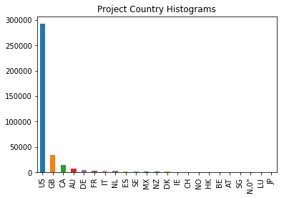

The three most frequent countries in the Kickstarter dataset are the United States (US), Great Britain (GB), and Canada (CA). Completing this analysis brought to the group's attention a misnomer in the data – 234 observations with a country value of "N,0"", which is not a valid country code. These observations were removed from the dataset.

# Initial Transformations

In addition to the analysis completed on the categorical and numeric features found within the Kickstarter dataset, two transformations were completed before algorithm application. The first transformation addressed Kickstarter campaigns without names, or titles. This issue impacted four records, and the group converted the name to the value of "Unknown". The second transformation dealt with invalid data types for the dataset. The Pandas library applied the wrong data type to a few of the features. The impacted features included *deadline*, *launched*, *usd_goal_real*, and *usd_pledged_real*. The *deadline* and *launched* features were converted to dates, removing time from the observations. The *usd_goal_real* and *usd_pledged_real* features were converted to integer data types. Transformations were applied to align the working dataset with the data types presented on the project's Kaggle site.

In the end, the group created a calculated column called *duration*, defined as the difference in days between the *deadline* and *launched* dates for a project. The group felt as though *duration* was a better feature to use than taking two arbitrary dates associated with the project. After completing transformations, the group reviewed which features were most important using correction matrix, recursive feature elimination and extra trees classifier.

# Feature Importance

The group applied logistic and linear regression independently on the remaining features of the training dataset to identify which features were most important, and to compare and contrast the results of both approaches. *Deadline*, *launched*, *ID*, and *currency* were removed from this analysis. It was determined that ID held very little predictive power, if any at all. The currency feature was highly correlated with country and may potentially skew the results of the algorithm. The group also converted all non-numeric values to numeric using the LabelEncoder method of the sklearn.preprocessing library. The inputs of the recursive feature importance algorithms must be important features in the dataset. After numeric transformation, the features were split into two subsets – features and target using the training dataset. Every feature that may influence the result of the project state was assigned to the "feature" subset, and the state feature was assigned to the "target" subset. After executing the recursive feature elimination algorithm, leveraging logistic regression and linear regression, the top three features are as follows:

|  |  |
| --- | --- |
| Recursive Feature Elimination Methodology | Top Three Features |
| Logistic Regression | backers, duration, country_cd |
| Linear Regression | main_category, duration, country_cd |

In addition to recursive feature elimination, the group also executed extra trees classifier to identify the associated feature importance of every feature in relation to the project's state. Please find a graph and table of the algorithm results on the following page.

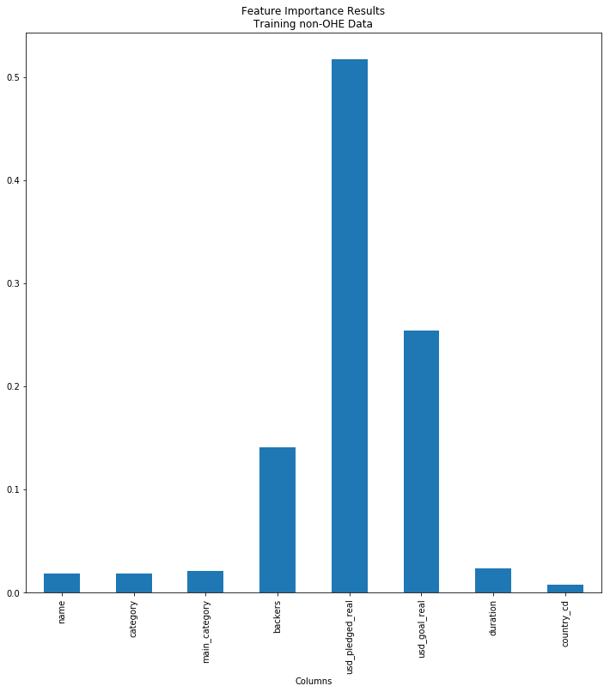

|  |  |
| --- | --- |
| Columns | Feature Importance |
| name | 0.018291 |
| category | 0.018090 |
| main_category | 0.021269 |
| backers | 0.140421 |
| usd_pledged_real | 0.517425 |
| usd_goal_real | 0.254266 |
| duration | 0.022962 |
| country_cd | 0.007275 |

The top three features according to extra trees classifier are *usd_pledged_real*, *usd_goal_real*, and *backers*. Of the eight features submitted to the feature importance algorithms, none of thefeatures were selected unanimously across all three algorithms. After filtering and transforming the data, as well as analyzing the importance of each feature to the target variable, the group applied feature importance algorithms to the training dataset with the OneHotEncoder method.

Due to the desire to contrast the results of feature importance before and after the application of the OneHotEncoder method, the group created a feature importance dataset as a copy of the training dataset within the OneHotEncoder method applied and applied the same feature importance algorithms. Please find the results of the recursive feature algorithms below:

|  |  |
| --- | --- |
| Recursive Feature Elimination Methodology | Top Three Features |
| Logistic Regression | backers, usd_goal_real, duration |
| Linear Regression | 10 (Singapore), 20 (Hong Kong), 21 (United States) |

In addition to the recursive feature elimination algorithms, the group also executed the extra trees classifier algorithm to find the relative importance of each feature to the target. Please find a graph and condensed table with the top five features on the next page.

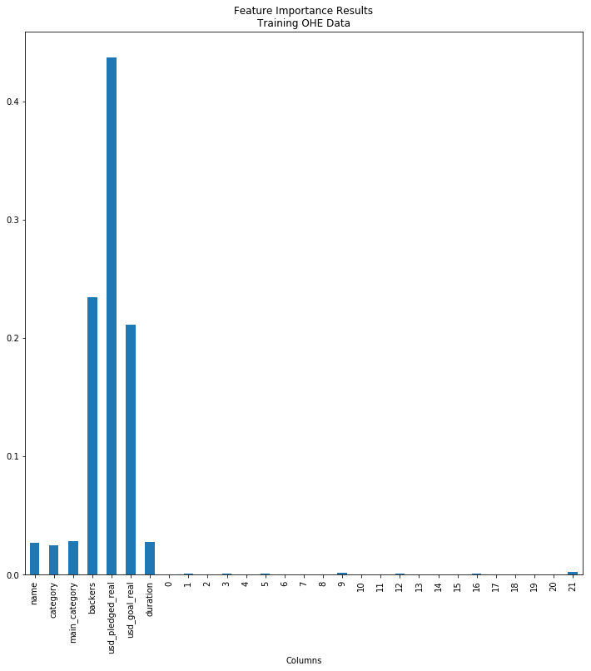

|  |  |
| --- | --- |
| Columns | Feature Importance |
| name | 0.026875 |
| category | 0.025006 |
| main_category | 0.027939 |
| backers | 0.234436 |
| usd_pledged_real | 0.437207 |
| usd_goal_real | 0.211240 |
| duration | 0.027550 |
| 0 | 0.000165 |
| 1 | 0.000650 |
| 2 | 0.000152 |
| 3 | 0.000736 |
| 4 | 0.000163 |
| 5 | 0.000618 |
| 6 | 0.000247 |
| 7 | 0.000370 |
| 8 | 0.000366 |
| 9 | 0.001274 |
| 10 | 0.000199 |
| 11 | 0.000185 |
| 12 | 0.000657 |
| 13 | 0.000032 |
| 14 | 0.000031 |
| 15 | 0.000320 |
| 16 | 0.000396 |
| 17 | 0.000151 |
| 18 | 0.000257 |
| 19 | 0.000274 |
| 20 | 0.000195 |
| 21 | 0.002311 |

It’s interesting to note the importance each country has on a project’s outcome. After completing a series of feature importance algorithms and comparing the requisite results, the group applied additional transformations to the dataset, as well as machine learning algorithms.

# Additional Transformations

Before splitting the dataset into test and train subsets, project *state* was reduced to True and False, where projects with a state "of successful" were set to true and all other projects states were set to False. The rationale behind this transformation was to reduce the complexity of project state and reduce the outcomes from 4 values to 2. Please see the following table for reference.

|  |  |  |
| --- | --- | --- |
| Project State after Transformation | Project State | Observation Count |
| True | successful | 133,956 |
| False | failed | 197,719 |
| canceled | 38,779 |
| suspended | 1,846 |

In addition to transforming project state, *country* were transformed using the LabelEncoder and OneHotEncoder methods of the sklearn.preprocessing library into 22 binary features; one country per feature. The group fits OneHotEncoder to the list of countries in the training dataset and transform both training and testing datasets based on the fitted OneHotEncoder. This method is especially useful when feeding categorical data into a sklearn pipeline. The following table shows 5 sample rows of features after transformation.

| **backers** | **usd_pledged_real** | **usd_goal_real** | **duration** | **0** | **1** | **2** | **3** | **...** | **17** | **18** | **19** | **20** | **21** |
| --- | --- | --- | --- | --- | --- | --- | --- | --- | --- | --- | --- | --- | --- |
| 48 | 4021 | 183515 | 30 | 0.0 | 0.0 | 0.0 | 0.0 | ... | 0.0 | 0.0 | 0.0 | 0.0 | 0.0 |
| 0 | 0 | 43929 | 25 | 0.0 | 0.0 | 0.0 | 1.0 | ... | 0.0 | 0.0 | 0.0 | 0.0 | 0.0 |
| 9 | 604 | 8000 | 31 | 0.0 | 0.0 | 0.0 | 0.0 | ... | 0.0 | 0.0 | 0.0 | 0.0 | 1.0 |
| 15 | 277 | 600 | 20 | 0.0 | 0.0 | 0.0 | 0.0 | ... | 0.0 | 0.0 | 0.0 | 0.0 | 1.0 |
| 3 | 232 | 130000 | 60 | 0.0 | 0.0 | 0.0 | 0.0 | ... | 0.0 | 0.0 | 0.0 | 0.0 | 1.0 |

# Model Execution and Analysis of Results

Once the necessary transformations were applied, the dataset is splitted to K-Nearest Neighbors (KNN) and logistic regression were applied to the dataset. The data went through many iterations of each test, with different parameters tweaked – mainly the number of neighbors in the KNN algorithm. The best performing model was a KNN algorithm with a leaf size of 30 and the number of neighbors set to five, using the minkowski distance metric. Two summary tables containing the best performing algorithms by micro and overall F1 score, respectively, can be found below.

|  |  |  |  |  |
| --- | --- | --- | --- | --- |
| Model Parameters | false | true | micro | Sum of Class F1 |
| N=5-Basic&Country | 1.0 | 1.00 | 1.0 | 3.00 |
| N=15-Basic&Country | 1.0 | 0.99 | 1.0 | 2.99 |
| N=11-Basic&Country | 1.0 | 1.00 | 1.0 | 3.00 |
| N=13-Basic&Country | 1.0 | 0.99 | 1.0 | 2.99 |
| N=3-Basic&Country | 1.0 | 1.00 | 1.0 | 3.00 |

*Best performing models, sorted by micro parameter*

|  |  |  |  |  |
| --- | --- | --- | --- | --- |
| Model Parameters | false | true | micro | Sum of Class F1 |
| N=5-Basic&Country | 1.0 | 1.0 | 1.0 | 3.0 |
| N=11-Basic&Country | 1.0 | 1.0 | 1.0 | 3.0 |
| N=3-Basic&Country | 1.0 | 1.0 | 1.0 | 3.0 |
| N=7-Basic&Country | 1.0 | 1.0 | 1.0 | 3.0 |
| N=9-Basic&Country | 1.0 | 1.0 | 1.0 | 3.0 |

*Best performing models, sorted by overall F1 score*

The best performing tops both lists and accurately predicted a project's success, or lack thereof, 99 percent of the time. To further underscore model performance, please find two confusion matrices that show the frequency / percentage of predicting the true label, as well as the frequency / percentage of predicting the false label, on the next page.

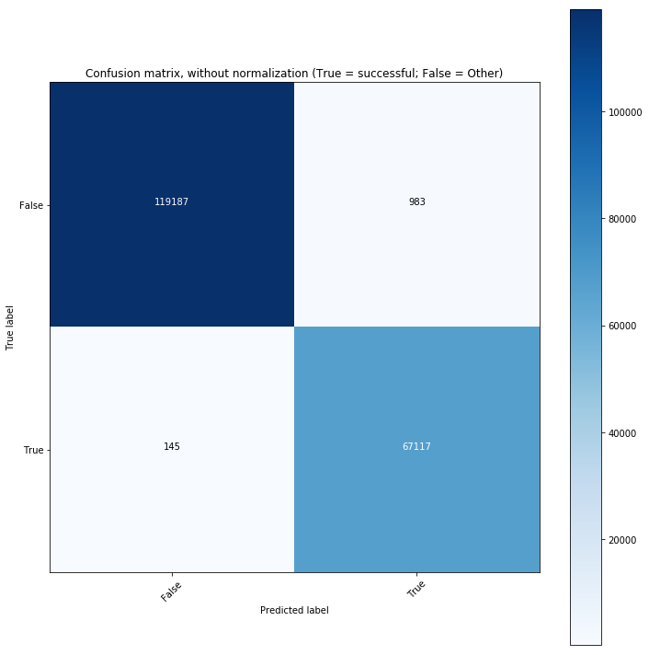

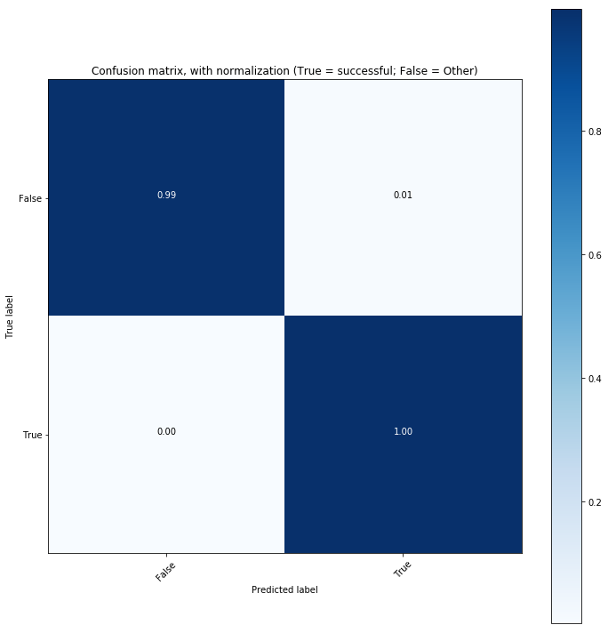

To underscore the performance of the model, please find a high-level classification report below.

|  |  |  |  |  |
| --- | --- | --- | --- | --- |
|  | precision | recall | f1-score | support |
| Failed/Cancelled/Suspended | 1.00 | 0.99 | 1.00 | 119,240 |
| successful | 0.99 | 1.00 | 1.00 | 66,793 |
| avg / total | 1.00 | 1.00 | 1.00 | 186,033 |

# Conclusion

In conclusion, the project group achieved the stated objective of predicting the success of a kickstart project based on the features provided. The top performing model was KNN with five neighbors, which accurately predicted if a project would succeed or fail 99 percent of the time. In addition to model execution, the project group also applied a series of algorithms to identify the most important features, derived the correlations between each feature in the dataset, and filtered or transformed anomalies in the data. Please find the requisite code used to complete the project within the following Appendix section.

# Appendix

# coding: utf-8

# # Kickstarter Projects

# ### CSC 478 Final Project

# #### Synopsis:

# * The purpose of this project is to predict whether a kickstarter campaign will fail, succeed, or cancel based on the available information available [here](https://raw.githubusercontent.com/stfox13/CSC478FinalProject/master/Data/ks-projects-201801.csv).

# * We will use an array of machine learning algorithms, including KNN, Linear Regression, Logistic Regression, and / or SVM to find the most accurate model.

# #### Contributors:

# * [Rebecca Tung (1448196)](https://github.com/rtungus)

# * [Sidney Fox (1524992)](https://github.com/stfox13)

get_ipython().magic(u'matplotlib inline')

import matplotlib.pyplot as plt

#import plotly.plotly as py

import numpy as np

import pandas as pd

import seaborn as sns

import os

import math

import requests

import datetime as dt

import matplotlib as mpl

import io

from pandas import Series, DataFrame

from sklearn.pipeline import Pipeline

from sklearn.neighbors import KNeighborsClassifier

from sklearn.linear_model import LogisticRegression, LinearRegression

from sklearn import preprocessing

from sklearn.preprocessing import StandardScaler, Imputer

from sklearn.ensemble import ExtraTreesClassifier

from sklearn import preprocessing

from sklearn import svm

from sklearn.metrics import f1_score, confusion_matrix, accuracy_score, classification_report

import itertools

from sklearn.feature_selection import RFE

from collections import defaultdict

from IPython.core.interactiveshell import InteractiveShell

InteractiveShell.ast_node_interactivity = "all"

#Set graph size

mpl.rcParams['figure.figsize'] = (12,12)

np.set_printoptions(suppress=True)

def roundup(x, y):

#return int(math.ceil(x / float(y))) * y

return int(math.ceil(x / y) * y)

# ## Load raw data as Pandas DataFrame:

url = 'https://raw.githubusercontent.com/stfox13/CSC478FinalProject/master/Data/ks-projects-201801.csv'

kickproj_org= pd.read_csv(url)

len(kickproj_org)

# ## Define Reuseful Function

def roundup(x, y):

#return int(math.ceil(x / float(y))) * y

return int(math.ceil(float(x) / float(y)) * y)

#Define a fuction to print and plot confusin matrix

def plot_confusion_matrix(cm, classes,

normalize=False,

title='Confusion matrix',

cmap=plt.cm.Blues):

"""

This function prints and plots the confusion matrix.

Normalization can be applied by setting `normalize=True`.

"""

if normalize:

cm = cm.astype('float') / cm.sum(axis=1)[:, np.newaxis]

#print("Normalized confusion matrix")

else:

#print('Confusion matrix, without normalization')

pass

# print(cm)

plt.imshow(cm, interpolation='nearest', cmap=cmap)

plt.title(title)

plt.colorbar()

tick_marks = np.arange(len(classes))

plt.xticks(tick_marks, classes, rotation=45)

plt.yticks(tick_marks, classes)

fmt = '.2f' if normalize else 'd'

thresh = cm.max() / 2.

for i, j in itertools.product(range(cm.shape[0]), range(cm.shape[1])):

plt.text(j, i, format(cm[i, j], fmt),

horizontalalignment="center",

color="white" if cm[i, j] > thresh else "black")

plt.tight_layout()

plt.ylabel('True label')

plt.xlabel('Predicted label')

#Define a fuction to calculate and print TP, TN, FP, and FN for each category

def show_statistics(test_y, y_pred, matrix):

TP = np.diag(matrix)

FP = np.sum(matrix, axis=0) - TP

FN = np.sum(matrix, axis=1) - TP

TN = []

for i in range(len(matrix)):

temp = np.delete(matrix, i, 0) # delete ith row

temp = np.delete(temp, i, 1) # delete ith column

TN.append(sum(sum(temp)))

temp_dic = {'TP': TP, 'FP' : FP,

'TN' : TN, 'FN' : FN}

scoreMatrix = DataFrame.from_dict(temp_dic)

#print "TP, TN, FP, FN for each cateory: "

return scoreMatrix

# Define a fuction to print F1 Score for each class and global (micro)

def formatResult(preResult, columnNames):

resultDF = DataFrame(preResult.values(), columns=columnNames, index=preResult.keys())

resultDF.loc['sum'] = np.sum(preResult.values(), axis=0)

resultDF['Sum of Class F1'] = np.append(np.sum(preResult.values(), axis=1), np.NaN)

return resultDF

#######KNN############

#Define a function to run KNeighborsClassifier with different n_neighbors and store f1 score

def runKNN(trainX, trainY, testX, testY, number, f1_only = False, trainSetName = '', dic_result_knn = {}):

i = 3

cls = KNeighborsClassifier(n_neighbors=i)

while i <= number:

#print i

cls = KNeighborsClassifier(n_neighbors=i)

cls.fit(trainX, trainY)

predY = cls.predict(testX)

result = f1_score(testY, predY, average=None).round(2)

result = np.append(result, f1_score(testY, predY, average='micro').round(2))

#print results

dic_result_knn['N=' + str(i) +'-' + trainSetName] = result

#print "n_neighbors = " + str(i) + " : " + result

i = i + 2

return dic_result_knn

#######LogisticRegression############

# Define a function to run LogisticRegression with different class_weight settings and store f1 score

def runLogistic(trainX, trainY, testX, testY, f1_only = False, trainSetName = '', dic_result_log = {}):

cls = LogisticRegression()

cls.fit(trainX, trainY)

predY = cls.predict(testX)

result = f1_score(testY, predY, average=None).round(2)

result = np.append(result, f1_score(testY, predY, average='micro').round(2))

#print results

dic_result_log['CWeight = None - ' + trainSetName] = result

cls = LogisticRegression(class_weight='balanced')

cls.fit(trainX, trainY)

predY = cls.predict(testX)

result = f1_score(testY, predY, average=None).round(2)

result = np.append(result, f1_score(testY, predY, average='micro').round(2))

#print results

dic_result_log['CWeight = balanced - ' + trainSetName] = result

return dic_result_log

#######SVM############

# Define a function to run SVM with different kernel settings and store f1 score

def runSVM(trainX, trainY, testX, testY, f1_only = False, trainSetName = '', dic_result_log = {}):

C = 1.0 # SVM regularization parameter

svc = svm.SVC(kernel='linear', C=C, decision_function_shape='ovr').fit(trainX, trainY)

predY = svc.predict(X_plot)

result = f1_score(testY, predY, average=None).round(2)

result = np.append(result, f1_score(testY, predY, average='micro').round(2))

print results

dic_result_log['SVCKernel = linear - ' + trainSetName] = result

svc = svm.SVC(kernel='rbf', C=C, decision_function_shape='ovr').fit(trainX, trainY)

predY = svc.predict(X_plot)

result = f1_score(testY, predY, average=None).round(2)

result = np.append(result, f1_score(testY, predY, average='micro').round(2))

print results

dic_result_log['SVCKernel = rbf - ' + trainSetName] = result

#svc = svm.SVC(kernel='poly', C=C, decision_function_shape='ovr').fit(trainX, trainY)

#predY = svc.predict(X_plot)

#result = f1_score(testY, predY, average=None).round(2)

#result = np.append(result, f1_score(testY, predY, average='micro').round(2))

#print results

#dic_result_log['SVCKernel = poly - ' + trainSetName] = result

return dic_result_log

# ## Check the Y data:

#Plot histogram

kickproj_org['state'].value_counts().plot(kind='bar', title='Project State Histograms')

# ### Drop projects when the state is equal to "undefined":

# Remove state = 'undefined'

kickproj = kickproj_org[(kickproj_org['state'] != 'undefined') & (kickproj_org['state'] != 'live')]

len(kickproj)

kickproj['state'].value_counts().plot(kind='bar', title='Project State Histograms')

kickproj.head(5)

# #### Since we have the goal and pledge amounts converted to US dollars (usd), we will drop the original goal and pledged columns:

#kickproj = kickproj[kickproj.columns.difference(['goal','pledged','usd pledged'])]

kickproj = kickproj.drop(['goal','pledged','usd pledged'], axis=1)

len(kickproj)

kickproj.head(5)

# ## Check the X data:

kickproj.describe()

print('Heat Map of Correlation Coefficients:')

min_periods=1).round(3), cmap=sns.diverging_palette(10, 220, sep=80, n=7), linewidths=0.1, annot=True, vmin=-1, vmax=1)

sns.heatmap(kickproj.apply(lambda x : pd.factorize(x)[0]).corr(method='pearson', min_periods=1).round(3), cmap='RdYlBu', linewidths=0.1, annot=True, vmin=-1, vmax=1)

categoryDF = kickproj.groupby(['category']).size().reset_index(name='counts')

len(categoryDF)

categoryDF.head(5)

kickproj.groupby(['main_category']).size().reset_index(name='counts')

kickproj['main_category'].value_counts().plot(kind='bar', title='Project Main Category Histograms')

cateDF = kickproj.groupby(['main_category', 'category']).size().reset_index(name='counts')

len(cateDF)

cateDF.head(40)

kickproj.groupby(['country']).size().reset_index(name='counts')

kickproj['country'].value_counts().plot(kind='bar', title='Project Country Histograms')

# ### Remove country with invalid value, N,0"

kickproj = kickproj[kickproj['country'] != 'N,0"']

kickproj.groupby(['country']).size().reset_index(name='counts')

kickproj['country'].value_counts().plot(kind='bar', title='Project Country Histograms')

# ### Check null value

null_columns=kickproj.columns[kickproj.isnull().any()]

null_columns

kickproj[null_columns].isnull().sum()

kickproj[kickproj["name"].isnull()][null_columns]

# ### Replace nan with Unknow for name

kickproj["name"].fillna('Unknown', inplace=True)

null_columns=kickproj.columns[kickproj.isnull().any()]

null_columns

# ### Apply correct data types to DataFrame:

print 'Data types do not align with the data types defined in the data dictionary:\n\n', kickproj.dtypes

# Columns that are of date data type:

datecols = ['deadline','launched']

# Columns that are of int data type:

intcols = ['usd_pledged_real','usd_goal_real']

for col in datecols:

kickproj[col] = pd.to_datetime(kickproj[col])

kickproj[col] = [d.date().toordinal() for d in kickproj[col]]

kickproj[intcols] = kickproj[intcols].fillna(0).astype(np.int64)

kickproj['duration'] = abs(kickproj['deadline']-kickproj['launched'])

print 'Review converted data types:\n\n', kickproj.dtypes

# ### Check the range of usd_pledged_real and usd_goal_real

binrange = range(1, roundup(max(kickproj['usd_pledged_real']),100000), 5000000)

binrange

min(kickproj['usd_goal_real'])

max(kickproj['usd_goal_real'])

min(kickproj['usd_pledged_real'])

max(kickproj['usd_pledged_real'])

# ### Check whether All successful records have usd_pledged_real > 0 - Outliners to be removed

# All successful records have usd_pledged_real > 0? - There is one record with excpetion and we remove it

min(kickproj['usd_pledged_real'])

x = kickproj[(kickproj['usd_pledged_real']==0) & (kickproj['state']=='successful')].index

kickproj.drop(x, inplace=True)

kickproj[(kickproj['usd_pledged_real']==0) & (kickproj['state']=='successful')]

# ### Find out correlation among variables

# 1. ** Feature X - backer (0.33), duration (0.11), usd_pledged_real(0.45), usd_goal_real (-0.07), currency (-0.05) and country (-0.04) are strongly correlated with State (Target Variable) **

# 2. ** Currency and Country are highly correlated (0.94). Only one should be used in the model. We decide to go with Country **

# 3. ** Duration is derived from deadline and launched. Duration will be used instead of deadline and launched in the model.**

print('Heat Map of Correlation Coefficients:')

#sns.heatmap(kickproj.apply(lambda x : pd.factorize(x)[0]).corr(method='pearson', min_periods=1).round(3), cmap=sns.diverging_palette(10, 220, sep=80, n=7), linewidths=0.1, annot=True, vmin=-1, vmax=1)

sns.heatmap(kickproj.apply(lambda x : pd.factorize(x)[0]).corr(method='pearson', min_periods=1).round(3), cmap='RdYlBu', linewidths=0.1, annot=True, vmin=-1, vmax=1)

# ### Shuffle the dataset and create training and test datasets

shffled_kickproj = kickproj.sample(frac=1)

# #### Convert the value of state to True (success) or False (Other)

shffled_kickproj['state_cd'] = shffled_kickproj['state'].apply(lambda a: True if a == 'successful' else False)

shffled_kickproj.head(5)

# #### Convert each country to a number

le = preprocessing.LabelEncoder()

le.fit(shffled_kickproj['country'])

shffled_kickproj['country_cd'] = le.transform(shffled_kickproj['country'])

shffled_kickproj.head(5)

num = shffled_kickproj.shape[0]/2

fi_vals, train_x, train_y = shffled_kickproj.iloc[0:num, [1,2,3,4,5,6,7,8,9,10,11,12,13,14]], shffled_kickproj.iloc[0:num, [8,9,10,11,12,14]], shffled_kickproj.iloc[0:num, 13]

test_x, test_y = shffled_kickproj.iloc[num:, [8,9,10,11,12,14]], shffled_kickproj.iloc[num:, 13]

train_x.head(2)

train_x.shape

train_y.head(2)

train_y.shape

test_x.head(2)

test_x.shape

test_y.head(2)

test_y.shape

# ### Train training set

# #### Convert country using oneHotEncoder

temp_features_train = train_x['country_cd'].reshape(-1, 1) # Needs to be the correct shape

temp_features_test = test_x['country_cd'].reshape(-1, 1) # Needs to be the correct shape

ohe = preprocessing.OneHotEncoder(sparse=False) #Easier to read

#fit on training set only

ohe.fit(temp_features_train)

countryDF_train = DataFrame(ohe.transform(temp_features_train), columns = ohe.active_features_, index = train_x.index)

countryDF_test = DataFrame(ohe.transform(temp_features_test), columns = ohe.active_features_, index = test_x.index)

countryDF_train.head(10)

countryDF_test.head(10)

train_x.shape

countryDF_train.shape

test_x.shape

countryDF_test.shape

train_X1 = pd.merge(train_x.drop(['country','country_cd'], axis=1), countryDF_train, left_index=True, right_index=True)

train_X1.head(10)

train_X1.shape

test_X1 = pd.merge(test_x.drop(['country','country_cd'], axis=1), countryDF_test, left_index=True, right_index=True)

test_X1.head(10)

test_X1.shape

result_Dic = {}

#Call function to run KNeighborsClassifier with different n_neighbors settings (up to 20) and store the f1 score results

result_Dic = runKNN(train_X1, train_y.values.ravel(), test_X1, test_y.values.ravel(), 18, trainSetName = 'Basic&Country', dic_result_knn = result_Dic)

#Call function to run LogisticRegression with different class_weight settings (None or Balance) and store the f1 score results

result_Dic = runLogistic(train_X1, train_y.values.ravel(), test_X1, test_y.values.ravel(), trainSetName = 'Basic&Country', dic_result_log = result_Dic)

# Call function to run LogisticSVM with different kernel settings (linear, rbf or poly) and store the f1 score results

# result_Dic = runSVM(train_X1, train_y.values.ravel(), test_X1, test_y.values.ravel(), trainSetName = 'Basic&Country', dic_result_log = result_Dic)

#Store number of classes

n_classes = np.unique(shffled_kickproj['state_cd'])

n_classes

resultDF = formatResult(result_Dic, np.append(n_classes, 'micro'))

resultDF.head(10)

# Print out the top 10 Micro (overall) F1 score from all settings

resultDF.drop('sum').nlargest(5, 'micro')

resultDF.drop('sum').nlargest(5, 'Sum of Class F1')

knnClr = KNeighborsClassifier(n_neighbors=5)

knnClr.fit(train_X1, train_y.values.ravel())

final_y_pred = knnClr.predict(test_X1)

# Compute confusion matrix

cnf_matrix = confusion_matrix(test_y, final_y_pred)

np.set_printoptions(precision=2)

# Plot non-normalized confusion matrix

plt.figure()

plot_confusion_matrix(cnf_matrix, classes=[False,True],

normalize=False,

title='Confusion matrix, without normalization (True = successful; False = Other)')

stats = show_statistics(test_y, final_y_pred, cnf_matrix)

strName = map((lambda a: 'successful' if a == True else 'Failed/Cancelled/Live/Suspended'), [False, True])

print "Classificaiton Reprt:"

print classification_report(test_y, final_y_pred, target_names=strName, digits=2)

# # Feature Importance

#Encode non-numeric variables - needed to run most of the models, understand anything feature importance:

le = preprocessing.LabelEncoder

d = defaultdict(le)

le_df = fi_vals.drop(

['currency','deadline','launched','country','state'], axis=1).apply(

lambda x: d[x.name].fit_transform(x))

le_features, le_target = le_df[le_df.columns.drop('state_cd')], le_df['state_cd']

#We'll look at recursive feature elimination (RFE) with logistic regression and select three features:

LogReg_RFE = RFE(LogisticRegression(), 3).fit(le_features, le_target)

print('The three most important features according to Logistic Regression:\n'),(np.array(le_features.columns)[LogReg_RFE.support_])

#We'll look at recursive feature elimination (RFE) with linear regression and select three features:

LinReg_RFE = RFE(LinearRegression(), 3).fit(le_features, le_target)

print('The three most important features according to Linear Regression:\n'),(np.array(le_features.columns)[LinReg_RFE.support_])

#We'll use extra trees classifier to calculate feature importance:

ETC = ExtraTreesClassifier().fit(le_features, le_target)

feat_imp_df = pd.DataFrame({'Columns':pd.Series(le_features.columns)})

feat_imp_df['Feature Importance'] = pd.Series(ETC.feature_importances_)

feat_imp_df.set_index(['Columns'],inplace=True)

print('Column Names and Associated Feature Importance:')

feat_imp_df

feat_imp_df.plot(kind="bar", title="Feature Importance Results\nTraining non-OHE Data", legend = False)

temp_features_fi = fi_vals['country_cd'].reshape(-1, 1) # Needs to be the correct shape

ohe = preprocessing.OneHotEncoder(sparse=False) #Easier to read

ohe.fit(temp_features_fi)

countryDF_fi = DataFrame(ohe.transform(temp_features_fi),

columns = ohe.active_features_, index = fi_vals.index)

fi_vals_ohe = pd.merge(fi_vals.drop(['country','country_cd'], axis=1), countryDF_fi, left_index=True, right_index=True)

fi_vals_ohe

ohe_df = fi_vals_ohe.drop(

['currency','deadline','launched','state'], axis=1).apply(

lambda x: d[x.name].fit_transform(x))

ohe_features, ohe_target = ohe_df[ohe_df.columns.drop('state_cd')], ohe_df['state_cd']

#We'll look at recursive feature elimination (RFE) with logistic regression and select three features:

LogReg_RFE = RFE(LogisticRegression(), 3).fit(ohe_features, ohe_target)

print('The three most important features according to Logistic Regression:\n'),(np.array(ohe_features.columns)[LogReg_RFE.support_])

#We'll look at recursive feature elimination (RFE) with linear regression and select three features:

LinReg_RFE = RFE(LinearRegression(), 3).fit(ohe_features, ohe_target)

print('The three most important features according to Linear Regression:\n'),(np.array(ohe_features.columns)[LinReg_RFE.support_])

np.unique(fi_vals[['country','country_cd']].values)

#We'll use extra trees classifier to calculate feature importance:

ETC = ExtraTreesClassifier().fit(ohe_features, ohe_target)

feat_imp_df = pd.DataFrame({'Columns':pd.Series(ohe_features.columns)})

feat_imp_df['Feature Importance'] = pd.Series(ETC.feature_importances_)

feat_imp_df.set_index(['Columns'],inplace=True)

print('Column Names and Associated Feature Importance:')

feat_imp_df.sort_values(by=['Feature Importance'])

feat_imp_df.plot(kind="bar", title="Feature Importance Results\nTraining OHE Data", legend = False)

1. Kemical. "Kickstarter projects." Kaggle.com.

   https://www.kaggle.com/kemical/kickstarter-projects (accessed February 13, 2018).